Installation

The G/L Source Names Extension is installed in the Extension Management page. You can access this page by searching
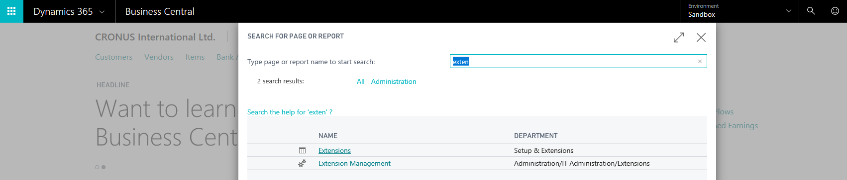
or via the Business Manager role center.
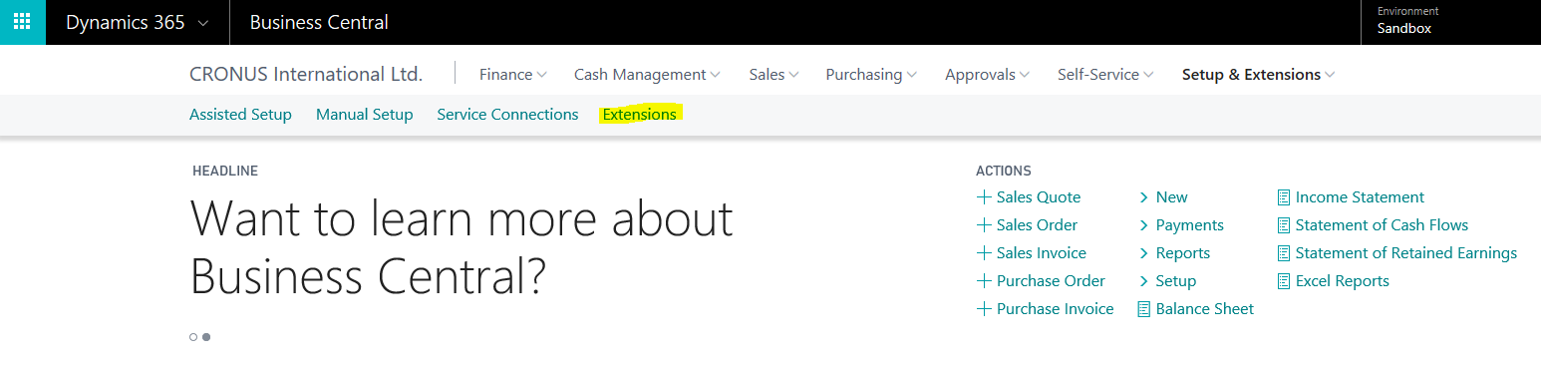

In the Extension Management page, you will find the installation for the G/L Source Names.
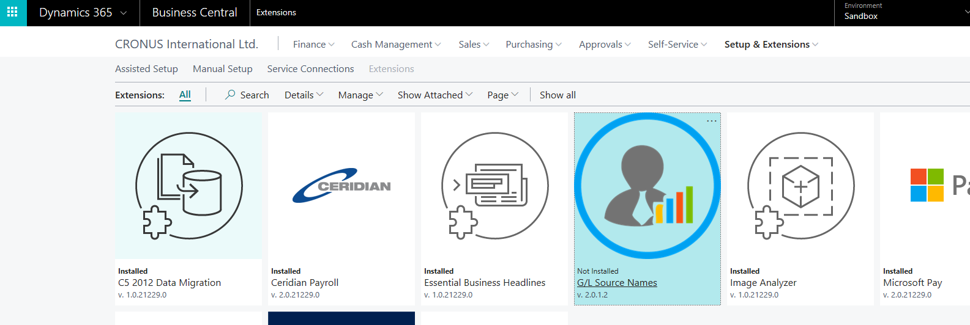

Click on the extension logo to install the extension.
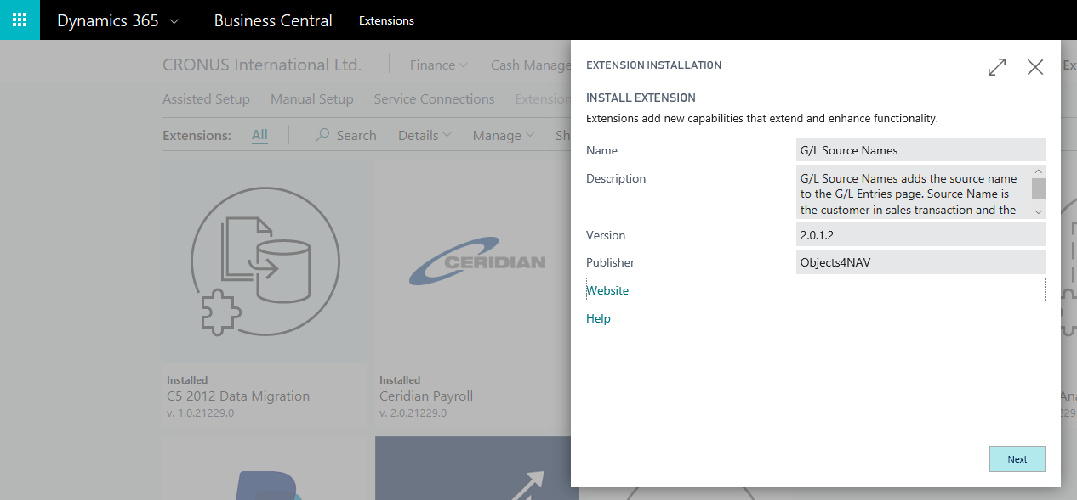
Press Next
Follow the link to Terms and Conditions before accepting and installing.
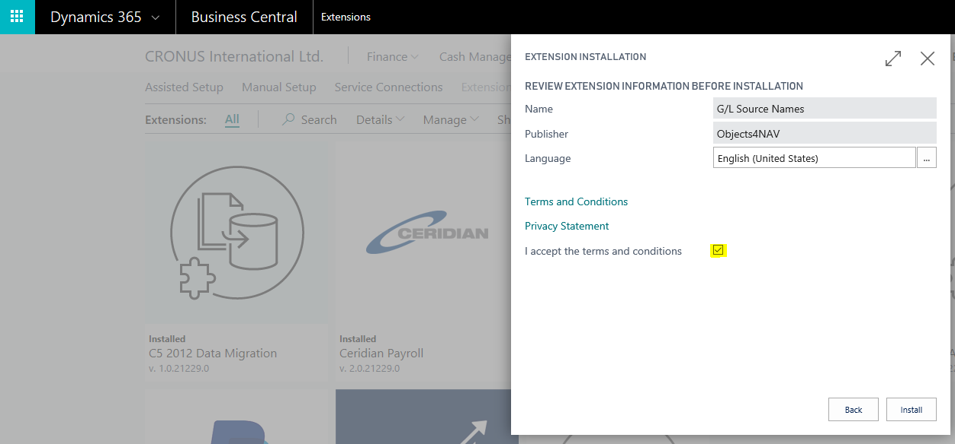
After a successful installation the user must log out of the system and login again.

Assisted Setup

The G/L Source Names Extension has an Assisted Setup Wizard. To access this wizard page by searching
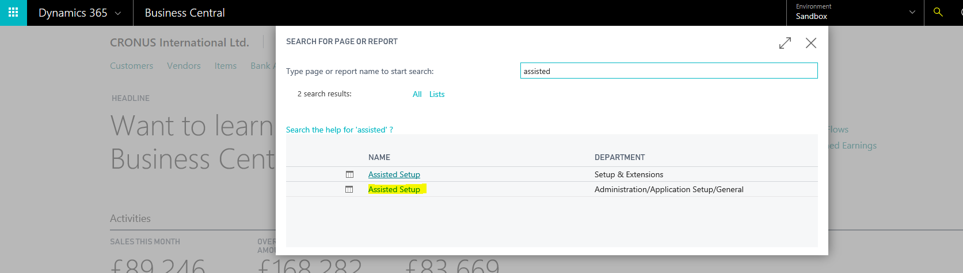
Or via the Business Manager role center
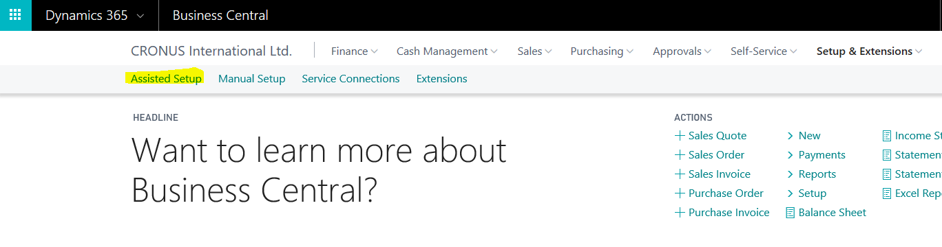
When inside the Assisted Setup page locate the line for the G/L Source Names setup.
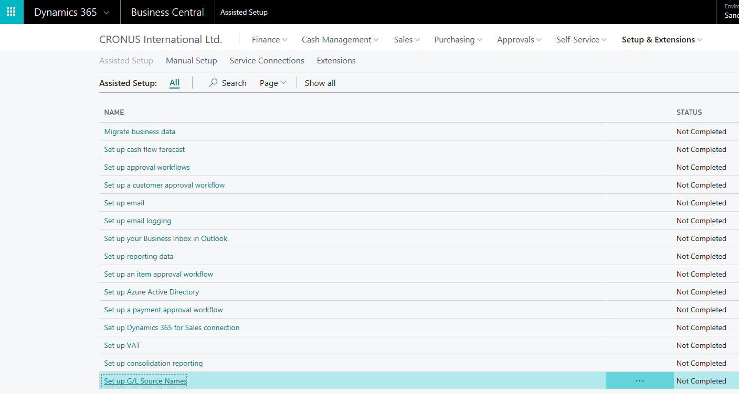
Click on the text or use the Start Setup action in the ribbon. This will start the Assisted Setup Wizard.
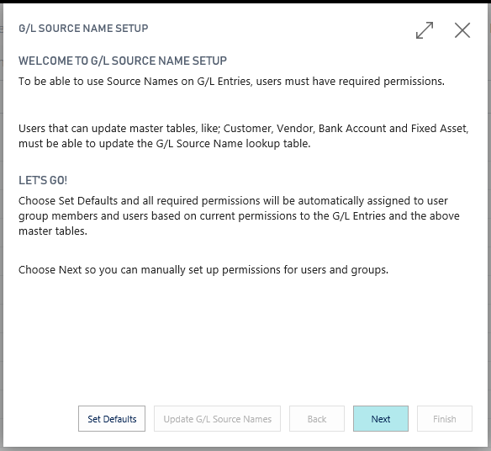
The wizard’s role is to make sure that every user has the required permissions to use the G/L Source Names extension. As stated in the wizard’s welcome page you have the option to set defaults or manually step through the wizard.
Using defaults will assign all required permissions to users and user groups based on the previous permissions. The registration e-mail address will also be picked up from the Company Settings. This is the recommended way to complete the Assisted Setup Wizard. Click the Set Defaults button and it will take you to the last step of the wizard.
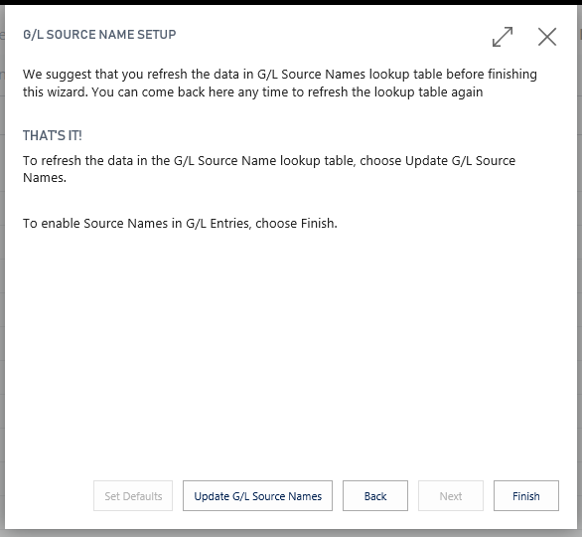
If you opt to a manual setup the steps will take you through four steps. You will manually assign permissions, read and write, to users and user groups. The wizard will only suggest users and user groups that have access to tables related to G/L Source Names. The first step is to assign read permission to user groups.
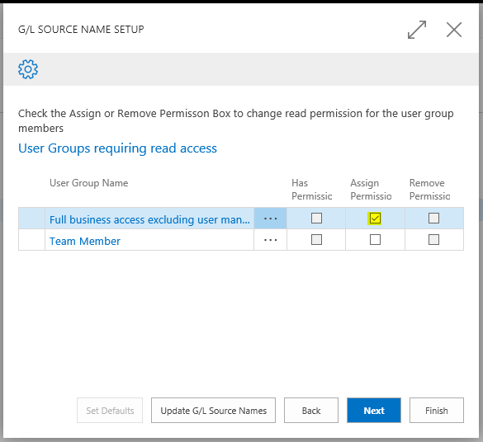
This is done by clicking the Assign Permission option for each line. If permission already exist it will be displayed in the Has Permission option. Next step is to assign update permission to user groups.
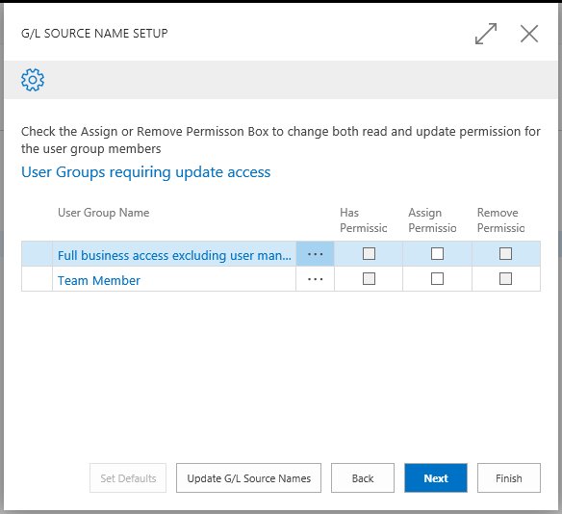
After completing the user group setup, the wizard will show the users that have access to G/L Source Names related tables. Some users have User Group Membership and therefore will have access even if you do not assign the permission to the user. In this demo both users are members of a user group and that is indicated in the wizard page.
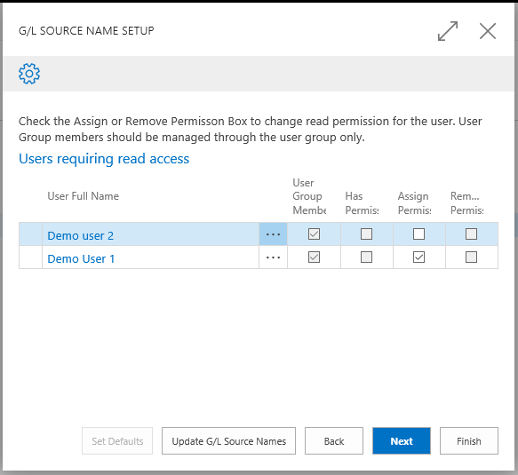
In this example the Demo user 2 is a Team Member. Since we did not assign permissions to the Team Member user group we can manually assign permission to each user. After completing the user read assignment you have to assign the update permissions for users.
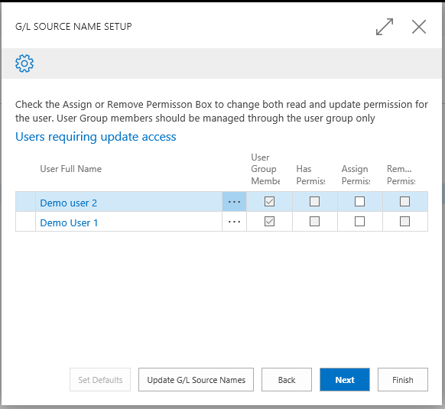
This conclude the permission management for the G/L Source Name Extension. In the final page we ask the user for a registration e-mail address. This e-mail address is not sent used in any way outside the G/L Source Name Extension.
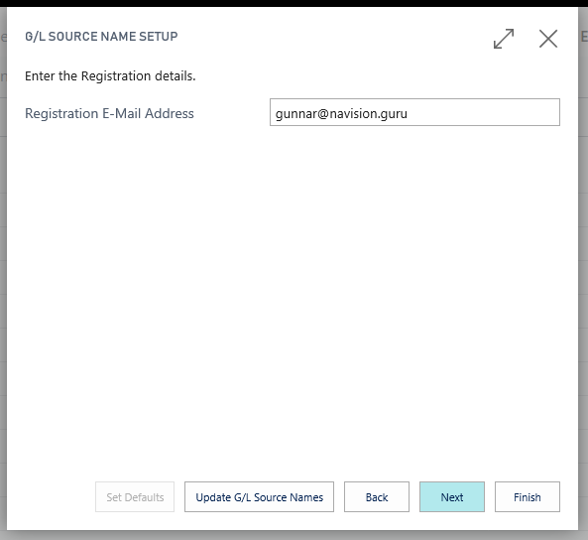
After the wizard has completed we suggest that you update the G/L Source Names lookup table before confirming the setup by pressing Finish.

Usage

The G/L Source Names Extension will add two fields to General Ledger Entry page. These fields will give the user information on the related master entry. This can be either; Customer, Vendor, Bank Account or Fixed Asset.
Go to the Chart of Accounts and locate an account that has sales entries. In this example we use the account no. 6110, domestic sales.
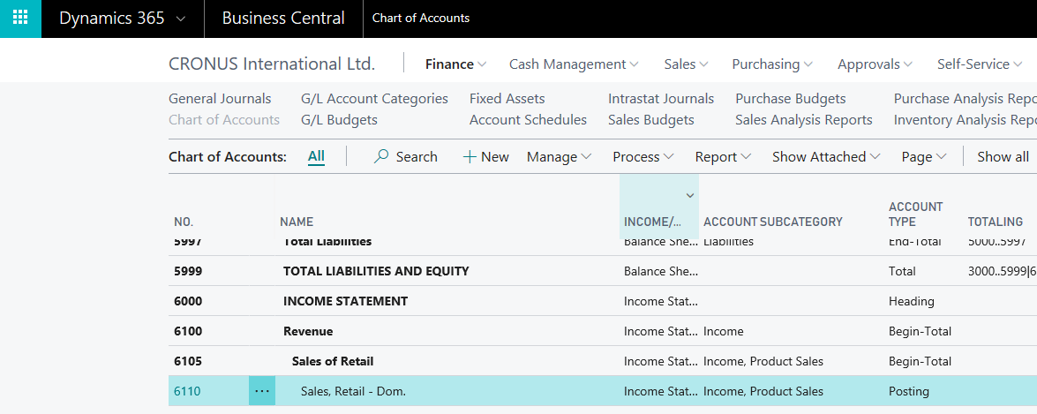
From the ribbon select the Ledger Entries
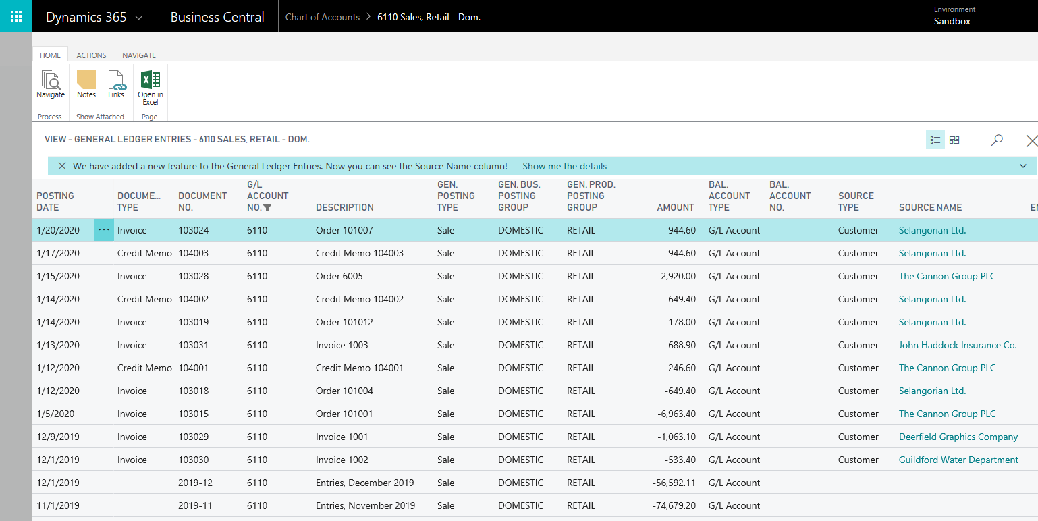
The two extra fields to this page are Source Type and Source Name. The user can drill down from the Source Name to the Source Card. There is also a new action on the ribbon to jump directly to the Source Card.

Behind the scenes

The G/L Source Names Extension will add a lookup table to Dynamics 365. When any of the four master tables; Customer, Vendor, Bank Account or Fixed Asset is updated an event subscription will make sure to update the lookup table.
It is therefore vital that all users that can update any of the master tables is assigned the required permission to update the lookup table. If a user is added to the system make sure to assign the correct user group and the required user permissions to that user. You can always verify that the required access is in place by stepping through the Assisted Setup Wizard.
There are three permission sets that are included with the Extension.
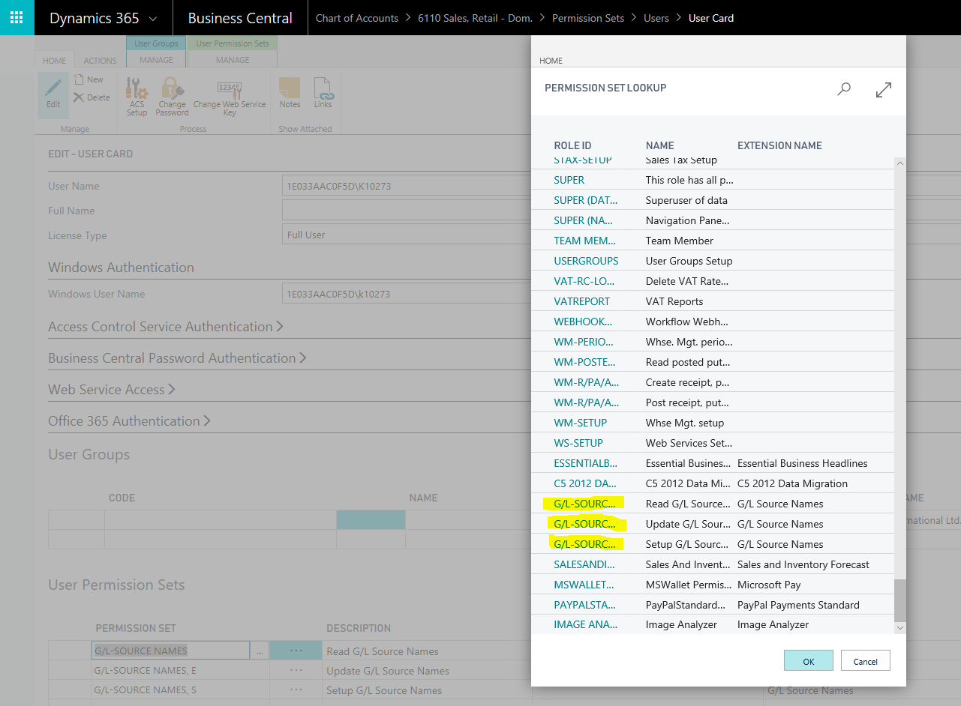
Every user that has permission to read G/L Entries should be assigned the “G/L-SOURCE NAMES” permission set directly or via the user group.
Every user that has permission to update any of the four master tables should be assigned the “G/L-SOURCE NAMES, E” permission set in a similar way.
A user that is allowed to run the Assisted Setup Wizard requires the “G/L-SOURCE NAMES, S”.
A user that has either the “SUPER” or “SUPER (DATA)” permission set already has access to all tables in Dynamics 365 Business Central.

